**FILE X’PLORE**

SUBMITTED BY:

**VISHAL MAURYA**

**RAJEEV SHARMA**

**SEAT NO: 42306 and 42338**

**JUNE – 2015**

**UNDER THE GUIDANCE OF Mr. TUSHAR SAMBARE**

**Submitted in partial fulfillment of the requirements for qualifying**

**M.Sc.-(I.T.), Semester – IV Examination**



Bunts Sangha's

**S.M.SHETTY COLLEGE OF SCIENCE,**

**COMMERCE & MANAGEMENT STUDIES**

**Opp. Jalvayu Vihar, Hiranandani Garden, Powai, Mumbai, Maharashtra 400076**

**ACKNOWLEDGEMENT**

It gives us great pleasure and pride as we present our project on “FILE X’PLORE”. This acknowledgement is a small effort to express our indebtedness and gratitude to all those who have shown us the path to bring out the colourful colours of this project with their vast treasures of experience and knowledge.

We express our deep sense of gratitude to our project guide persons for their timely encouragement, motivation and appraisal and for the solitude help and providing a sanctum atmosphere endeavoring to complete our project.

We express our deep sense of thanks and indebtedness towards our project guide Prof. Tushar Sambare. He has always made president efforts to carve keen interest and knowledge of subject on our mind.

We would also like to thank our entire department of Information Technology for their solitude help and providing sanctum atmosphere endeavoring to complete our project work.

We express our thanks to Prof. Ajay Shukla H.O.D of Information Technology for his help, directly and indirectly in completing our project work.

We would also like to express a feeling of gratitude to our parents and friends for their help directly or indirectly in completing our project work.

**Sincere thanks to,**

**Prof. Tushar Sambare**

**INDEX**

|  |  |  |
| --- | --- | --- |
| **SR NO.** | **TOPICS** | **PAGE NO.** |
|  | Synopsis | 4 |
|  | Objectives & Scope | 8 |
|  | Theoretical Background | 9 |
|  | Definition of Problem | 18 |
|  | PROPOSED SYSTEM | 20 |
|  | System Analysis and Design | 22 |
|  | System planning and Gantt Chart | 25 |
|  | Data Flow Diagram | 29 |
|  | Screenshots | 32 |
|  | Process involved | 58 |
|  | System Implementation and Details of Hardware and Software | 64 |
|  | System Maintenance and evaluation | 67 |
|  | Coding | 70 |
|  | Testing Methods | 84 |
|  | Future Enhancement | 88 |
|  | Bibliography | 89 |

**SYNOPSIS**

SYNOPSIS

**Title of the Project: *File X’plore***

**Objective of the Project: This project is aimed at developing** Android file manager Application **that depicts File X’plore and accessing the file and folders within the mobile.** **As well as the ability to view and manage the contents of your SD card or internal storage. The user with this application can access the following features of the application:**

* Root Explorer
* Different folder icons available.
* Different Text Color available.
* Choose appropriate gradient.
* Browse file from root directory.
* Set number of item in grid view.
* Hide and show files and directories.
* Mark files and folders.
* Search files.
* Refresh.
* Copy, Paste, Move, Rename and Delete file and folders.

Other features:

* **Image Viewer, Audio & Video player integrated.**
* **Share files.**

**Project Category: Smartphone Android-based App**

**Technology:** Android

**Technical Requirements:**

**SOFTWARE SPECIFICATION**

* Operating system- window Xp/7
* Java
* Eclipse
* Android SDK

**DEVICE HARDWARE REQUIREMENT:**

Min. Processor : ARM architecture, 200 MHz,

Operating System : Android

RAM : 128 MB, 512 recommended

Flash Memory : 256

Display : 3.5 inches or more screen size

**SYSTEM HARDWARE REQUIREMENT:-**

Processor : Intel Pentium i3 or higher

Processor speed : 2.3 GHz

Hard Disk Space : 160 GB (min.)

Ram Memory : 2 GB DDR3

Device : Android supported device

**MAIN REPORT**

**OBJECTIVES AND SCOPE**

**OBJECTIVES:**

* It provides a user interface to manage files and folders.
* It contains inbuilt **IMAGE VIEWER,AUDIO** and **VIDEO PLAYER**
* It provides with the feature of **HIDE** and **UNHIDES** files and folders.
* It gives the facility of ‘**Show Hidden Files**’.
* It helps to search the files within folder.

SCOPE:

The File X-plore file manager application provides the user to manage his/her files and folders.

The special feature of this application is:

* Basic function like Copy, Paste, Rename, Delete, Move files and folders.
* It have the functionality of sharing files on social media and between the different devices.
* With this application, multiple files and folders can be selected for deletion, sharing, copy and move.
* It have the feature of selecting different color for background, different folder icon can be chosen and text color can be changed.
* It reads all types of file extentions.
* Audios, Videos and Images are played by its inbuilt player.

**Theoretical Background**

**Introduction to ANDROID:-**

* ANDROID is a software stack for mobile devices that includes an operating system, middleware and key applications.
* A free, open‐source platform that any phone manufacturer can build with an application store that's hardly restricted at all.
* The Android open-source software stack consists of Java applications running on a Java-based, object-oriented application framework on top of Java core libraries running on a Dalvik virtual machine featuring JIT compilation.
* Android has a large community of developers writing applications that extend the functionality of the devices.

**2.6.1.1 HISTORY OF ANDROID:-**

* Android, Inc. was founded in Palo Alto, California, United States in October, 2003 by Andy Rubin, Rich Miner, Nick Sears and Chris White.
* In august, 2005 Google acquired Android Inc.
* On the November 5, 2007 the Open Handset Alliance, a consortium of several companies which include Broadcom Corporation, Google, HTC, Intel, LG, Marvell Technology Group, Motorola, NVidia, Qualcomm, Samsung Electronics, Sprint Nextel, T-Mobile and Texas Instruments unveiled itself.
* The goal of the Open Handset Alliance is to develop open standards for mobile devices.
* On November 12, 2007 Android Beta SDK released.

**2.6.1.2 Version History of Android:-**

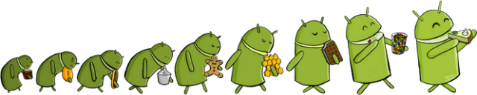

* **Android 1.0:-**
* On 23 November, 2008 the first android device, HTC Dream (G1) featuring Android 1.0.
* Integration with Google service.
* Web browser to show, zoom and pan full HTML and XHTML web page.
* Based on Linux Kernel.
* **Android 1.1**update for Android was released for T-Mobile G1 only on 9 February, 2009.
* **Android 1.5(Cupcake):-**



* On 30 April, 2009 based on Linux Kernel 2.6.27, the official Android 1.5(Cupcake), update for Android was released.
* Faster camera start-up and image capture.
* Much faster acquisition of GPS location.
* On-screen soft keyboard.
* Direct upload videos to YouTube and Picassa.
* **Android 1.6(Donut):-**



* On 15 September, 2009 based on Linux Kernel 2.6.29, the 1.6(Donut) SDK was released.
* Quick search box and voice search.
* Integrated camera, camcorder and gallery, toggle between still and video capture modes.
* Battery usage indicator.
* CDMA support.
* Multilingual text-to-speech function.
* **Android 2.0(Eclair):-**

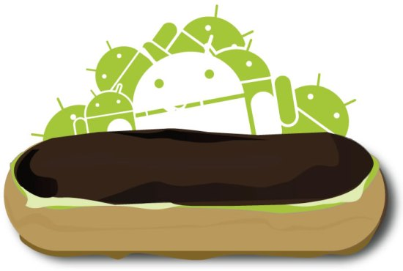

* On 26 October, 2009 based on Linux Kernel 2.6.29, the 2.0(Eclair) SDK was released.
* Multiple accounts for email and contact synchronization.
* Microsoft Exchange Support for syncing of e-mail.
* Bluetooth 2.1 support.
* New calendar features.

**Android 2.0.1**SDK was released on 3 December, 2009.

**Android 2.1**SDK was released on 12 January, 2010.

* **Android 2.2(Froyo):-**



* On 20 May, 2010 based on Linux Kernel 2.6.32, the 2.2(Froyo) SDK was released.
* New tips widget for home screen.
* Improved exchange support.
* Hotspot support.
* Multiple keyboard languages.
* Adobe flash 10.1.
* **Android 2.3(Gingerbread):-**



* On 6 December, 2010 the 2.3(Gingerbread) SDK was released.
* UI refinements for simplicity and speed.
* New keyboard for faster text input.
* One-touch word selection and copy/paste.
* Internet calling.

**Android 2.3.3**SDK was released on 22 February, 2011 based on Linux Kernel 2.6.35.

* **Android 3.0 (Honeycomb):-**

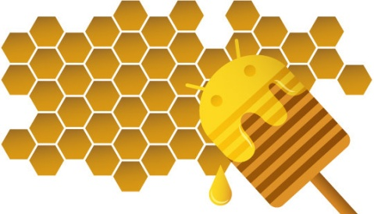

* On 22 February, 2011 based on Linux Kernel 2.6.36, the 3.0(Honeycomb) SDK was released for TABLETS.
* Specifically optimized for tablets and devices with large screen sizes.
* Refined multitasking, rich notifications, home screen customization, widgets.
* Bluetooth tethering.
* Built-in support for media/picture transfer protocol.
* **Android 3.1:-**
* Release date-10 may2011
* UI refinements
* Connectivity for USB accessories
* Expanded Recent Apps list
* Resizable Home screen widgets
* Support for external keyboards and pointing devices
* Support for joysticks and gamepads
* High-performance Wi-Fi lock, maintaining high-performance Wi-Fi connections when device screen is off
* Support for HTTP proxy for each connected Wi-Fi access point

**Android 3.2:-**

* Released on 15 July 2011
* Improved hardware support, including optimizations for a wider range of tablets
* Increased ability of apps to access files on the SD card, e.g. for synchronization
* Compatibility display mode for apps that have not been optimized for tablet screen resolutions
* New display support functions, giving developers more control over display appearance on different Android devices

**Android 3.2.1:-**

* Released on 20 September 2011
* Bug fixes and minor security, stability and Wi-Fi improvements
* Update to [Android Market](http://en.wikipedia.org/wiki/Android_Market) with automatic updates and easier-to-read Terms and Condition text
* Update to [Google Books](http://en.wikipedia.org/wiki/Google_Books)
* Improved [Adobe Flash](http://en.wikipedia.org/wiki/Adobe_Flash) support in browser
* Improved [Chinese](http://en.wikipedia.org/wiki/Chinese_language) handwriting prediction

**Android 3.2.2:-**

* Released on 30 August 2011
* Bug fixes and other minor improvements for the Motorola Xoom 4G

**Android 3.2.3:-**

* Bug fixes and other minor improvements for the Motorola Xoom 4G

**Android 3.2.4:-**

* Released on December 2011
* Pay as You Go" support for 3G and 4G tablets

**Android 3.2.5:-**

* Released on January 2012
* Bug fixes and other minor improvements for the Motorola Xoom and Motorola Xoom 4G

**Android 3.2.6:-**

* Released on February 2012
* Fixed data connectivity issues when coming out of airplane mode on the US 4G Motorola Xoom.
* **Android 4.0(Ice Cream Sandwich):-**

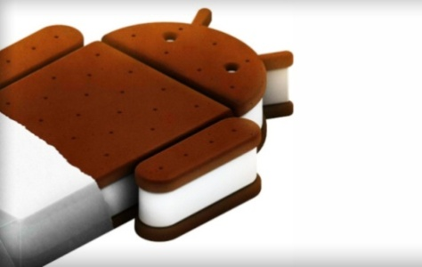

* Released on 19 October 2011
* Soft buttons from Android 3.x are now available for use on phones
* Separation of widgets in a new tab, listed in a similar manner to apps
* Easier-to-create folders, with a drag-and-drop style
* A customizable launcher
* Improved visual voicemail with the ability to speed up or slow down voicemail messages
* Pinch-to-zoom functionality in the calendar
* Integrated screenshot capture (accomplished by holding down the Power and Volume-Down buttons)
* Improved error correction on the keyboard
* Ability to access apps directly from lock screen
* Improved copy and paste functionality
* Better voice integration and continuous, real-time speech to text dictation
* Face Unlock, a feature that allows users to unlock handsets using facial recognition software

**Android 4.0.1:-**

* Released on 21 October 2011
* Fixed minor bugs for the Samsung Galaxy Nexus

**Android 4.0.2:-**

* Released on 28 November 2011
* Fixed minor bugs on the Verizon Galaxy Nexus, the US launch of which was later delayed until December 2011

**Android 4.0.3:-**

* Released on 16 December 2011
* Numerous bug fixes and optimizations
* Improvements to graphics, databases, spell-checking and Bluetooth functionality
* New APIs for developers, including a social stream API in the Contacts provider
* Calendar provider enhancements
* New camera apps enhancing video stabilization and [QVGA](http://en.wikipedia.org/wiki/Quarter_Video_Graphics_Array) resolution
* Accessibility refinements such as improved content access for screen readers
* Accessibility refinements such as improved content access for screen readers

**Android 4.0.4:-**

* Released on 29 march 2012
* Stability improvements
* Better camera performance
* Smoother screen rotation
* Improved phone number recognition

**DEFINITION OF PROBLEM**

**PROBLEM DEFINITION**

The problem of this application project is that it is built only for android based devices and it is not working on other platforms.

There are many of the file explorers are available, but they don’t gives facility to users while managing and exploring there files and folders on their devices. In order to hide sensitive data on the devices, multiples of users used to use different application. This causes them to deal with RAM/Memory spaces of their devices.

While doing this project we faced multiples of problems. While creating tabs we find that the tabs are not working as expected.

We faced problem on Renaming of files and folders. Creating a new folder on emulator gives problems that are unable to resolve.

It is not accepting new folder on AVD.

**PROBLEM SOLUTION**

Since, this application is built only for android platforms, in the future we will work on this project so that it will be able to run on other platforms like IOS and Windows.

This application provides user friendly features as like changing background color, text icon. If users want to hide their sensitive data on their devices, this application provides inbuilt features of “hide and unhide” of files and folders without using any other application for this purpose.

In order to solve tabs problem, we searched on internet and got ideas from ‘androiddevelopers.com’,’vogella.com’.

For creation of new folders problem, we got solution while running it on mobile device, because it have SD CARD and we gave SD CARD option by default in the code. Selecting SD CARD option. Folders cannot be created on a virtual device or emulator.

**PROPOSED SYSTEM**

The proposed system is an Android based Mobile Application software. Our application is more beneficial to the users those who want to multiples of functionality in a single software application.

The main aim is to provide users an application that have user friendly interface.

**Benefits of the proposed system:**

The application is user friendly.

**The user with this application have the following benefits:**

* Root Explorer
* Different folder icons available.
* Different Text Color available.
* Choose appropriate gradient.
* Browse file from root directory.
* Set number of item in grid view.
* Hide and show files and directories.
* Mark files and folders.
* Search files.
* Refresh.
* Copy, Paste, Move, Rename and Delete file and folders.

**SYSTEM ANALYSIS AND DESIGN**

**System Analysis**

"**Systems analysis** is a problem solving technique that decomposes a system into its component pieces for the purpose of the studying how well those component parts work and interact to accomplish their purpose".

System Analysis is the interdisciplinary part of science, dealing with analysis of sets of Interacting entities, the systems, often prior to their system. This field is closely related to Operation’s research. It is also “ann. explicit formal enquiry carried out to help someone, referred to as the decision maker identify a better course of action and make a better decision than he might have otherwise made”.

**Information Technology**

The development of a computer-based information system often comprises the use of system analyst. When a computer-based information system is developed, system analysis (according to the waterfall model) to constitute the following steps:-

* The development of a feasibility study, involving determining whether a project is economically, socially, technologically and organizationally feasible.
* Conducting fact-finding measures, design to ascertain the requirements of systems end users. This typically span interviews, questionnaires, or visual observation of work on the existing system.
* Gauging how the end-users would operate the system (in terms of the general experience in using computer hardware or software), what the system would be used for etc.

.

**REQUIREMENT SPECIFICATION**

**User requirement:**

The aim of developing this application is because currently 70-75% of users are using the android phone instead of other operating system based mobile phones.

The user can carry the application anywhere and can access the application everywhere and its user friendly that’s why we developed the application in android.

**SOFTWARE SPECIFICATION**

* Operating system- window Xp/7
* Java
* Eclipse
* Android SDK

**DEVICE HARDWARE REQUIREMENT:**

Min. Processor : ARM architecture, 200 MHz,

Operating System : Android

RAM : 128 MB, 512 recommended

Flash Memory : 256

Display : 3.5 inches or more screen size

**SYSTEM HARDWARE REQUIREMENT:-**

Processor : Intel Pentium i3 or higher

Processor speed : 2.3 GHz

Hard Disk Space : 160 GB (min.)

Ram Memory : 2 GB DDR3

Device : Android supported device

**SYSTEM PLANNING GANTT CHART**

**GANTT CHART**

A Gantt chart is a type of bar chart that illustrates a Project schedule .Gantt Chart illustrate the start status using and finish dates of the terminal elements and summary elements of a project. Terminal elements and summary elements comprise the work breakdown structure of the project. Some Gantt chart also shows the dependency relationship between activities.

Gantt charts have become a common technique for representing the phases and activities of a project work breakdown structure (WBS), so they can be understood by a wide audience.

A Gantt chart is a project management tool used to schedule, organize and co-ordinate tasks within a project. The Gantt chart is name after Charles Gantt, and is not an acronym. It is a schedule (time ordered listing) of planned events.

The Gantt chart is very useful way to present the general flow of a project’s tasks. Such charts are particularly useful for co-ordinating multiples activities. It also provides a useful way to track project progress against the plan and schedule. It is helpful tool to analyze the development process at stage of development and to find out problem in delays and mistake.

A Gantt chart is a type of [bar chart](http://en.wikipedia.org/wiki/Bar_chart), developed by [Henry Gantt](http://en.wikipedia.org/wiki/Henry_Gantt) in the 1910s, that illustrates a [project schedule](http://en.wikipedia.org/wiki/Schedule_(project_management)). Gantt charts illustrate the start and finish dates of the terminal elements and summary elements of a [project](http://en.wikipedia.org/wiki/Project).

Terminal elements and summary elements comprise the [work breakdown structure](http://en.wikipedia.org/wiki/Work_breakdown_structure) of the project. Some Gantt charts also show the [dependency](http://en.wikipedia.org/wiki/Dependency_(project_management)) (i.e., precedence network) relationships between activities.

Gantt charts can be used to show current schedule status using percent-complete shadings and a vertical "TODAY" line as shown here.

PLANNED

COMPLETED

|  |  |  |  |  |  |  |  |  |  |
| --- | --- | --- | --- | --- | --- | --- | --- | --- | --- |
|  | JAN (1-15) | JAN (16-31) | FEB  (1-15) | FEB (16-28) | MAR  (1-15) | MAR  (15-31) | MAY  (1-15) | MAY  (15-31) | JUN  (1-6) |
| ANALIYSIS   * Feasibility Study * Data Gathering * Documentation |  |  |  |  |  |  |  |  |  |
| DESIGNING   * Form Designing |  |  |  |  |  |  |  |  |  |
| CODING   * Form Coding * Report Coding |  |  |  |  |  |  |  |  |  |
| TESTING   * Implementation Of Single Forms * Entire System As A Whole |  |  |  |  |  |  |  |  |  |
| Project Report  Submission |  |  |  |  |  |  |  |  |  |

**PROJECT LIFE CYCLE**

**DATA FLOW DIAGRAM (DFD)**

A **Data-Flow Diagram (DFD)** is a graphical representation of the “flow” of data through an information system. DFDs can also be used for visualization of data processing (Structured Design) of a DFD, Data item Flow from an external data source or an internal data store to an internal data store or an external data link, via an internal process.

Data Flow Diagrams (DFD’s) are one of the three essential perspectives of the structured- system analysis and design method (SSADM).The sponsor of a project and the end users will need to be briefed and consulted throughout all stages of a system’s evolution. With a data- flow diagram, users are able to visualize how the system will operate, what the system will accomplish, and how the system will be implemented. The old system’s data flow diagrams can be drawn up and compared with the new system’s data flow diagram to draw comparisons to implement a more efficient system.

DFD is easy to read and understand. DFD are excellent mechanism for communicating with customers during requirement analysis; they are widely used for representation of external and top level internal design specification.

**Advantages of data flow diagram**:

.A simple graphical technique which is easy to understand.

· It helps in defining the boundaries of the system.

· It is useful for communicating current system knowledge to the users.

· It is used as the part of system documentation file.

· It explains the logic behind the data flow within the system.

**Disadvantages of data flow diagram:**

. Data flow diagram undergoes lot of alteration before going to users, so makes the process little slow.

· Physical consideration are left out.

· It make the programmers little confusing towards the system.

· Different DFD models have different symbols like in Gane and Sarson process is represented as rectangle where as in DeMarco and Yourdan symbol it is represented as eclipse.

**DATA FLOW DIAGRAM NOTATIONS**

There are different notations to draw data flow diagram, defining different visual representations for processes, data stores, data flow and external entities.

The data flow diagrams are composed of four basic symbols: Those are as:

A process or work to done.

A data flow or inputs or outputs; to and from processes

This represents external agents. They are the source

Or destination or data outside the system

C:\Users\Vishal M\Desktop\Capture.PNG The open-ended boxes represent data stores. Sometimes called files or database.

View Setting

User can change settings

Setting

Create File

Create File & Folders

Create File

Rename File & Folder

Rename

Delete Folder

Delete

Search Files & folders

Search

Delete from sd card

Search Files & folders

Sd Card

Sd Card

rename

Fetch all data

Add folder

Add Folder in SD Card

Add Folder

Sd Card

S1

List of Data

Sd Card

ACK

View

Users

Change Settting

**SCREEN SHOTS**

Home Page

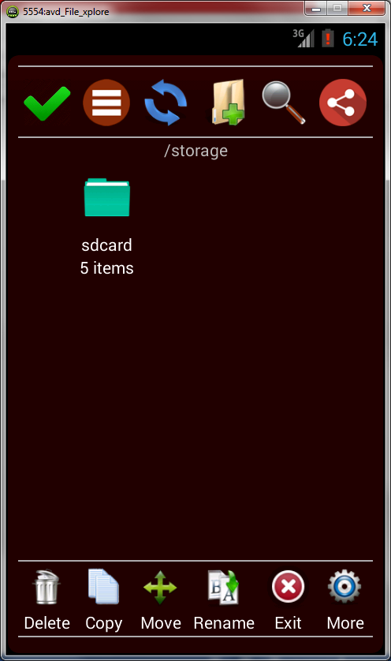

**About Us Page**

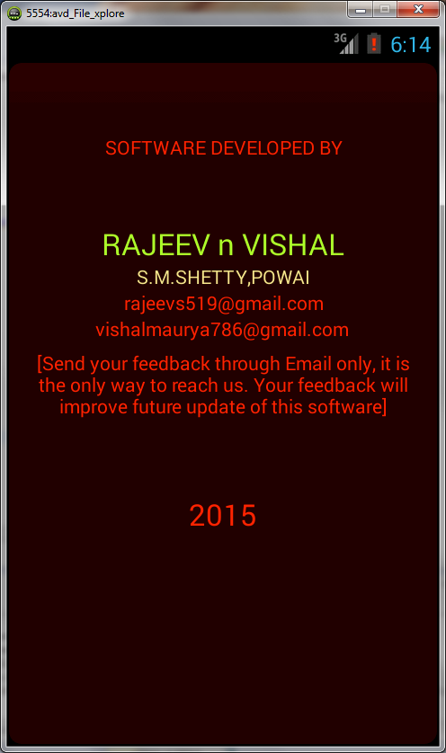

**Grid View page**

After selecting 2 from grid list After selecting 3 from grid list

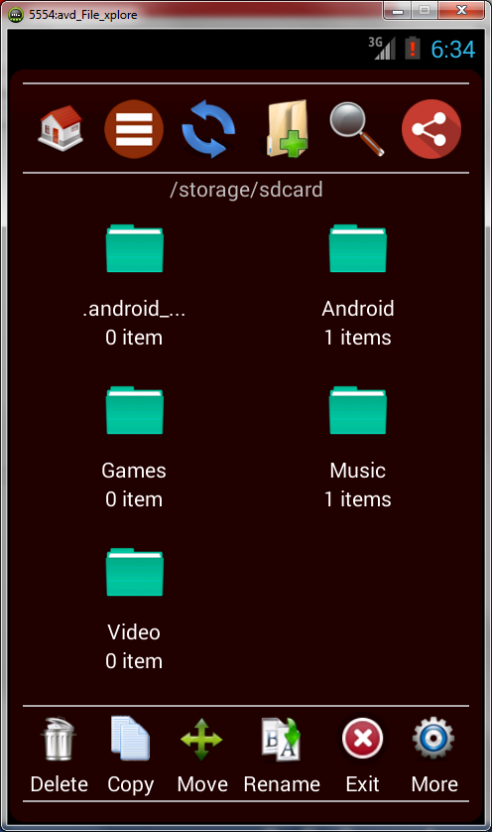 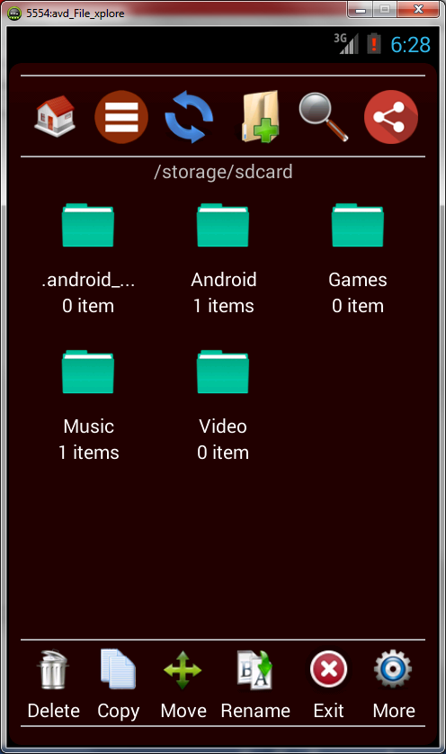

**Refresh Page**

For example: to change the background color, you have to select ‘Settings’ from “More” tab and select the background color you want to set in the background and press “Refresh” tab,

Before After refresh

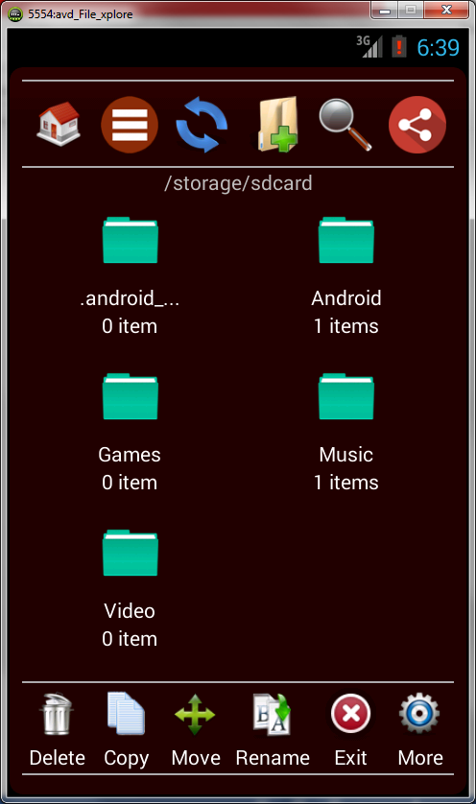 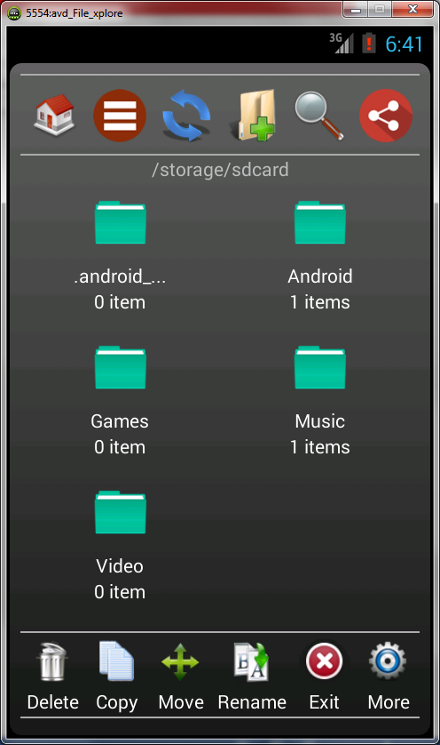

**NEW FOLDER page.**

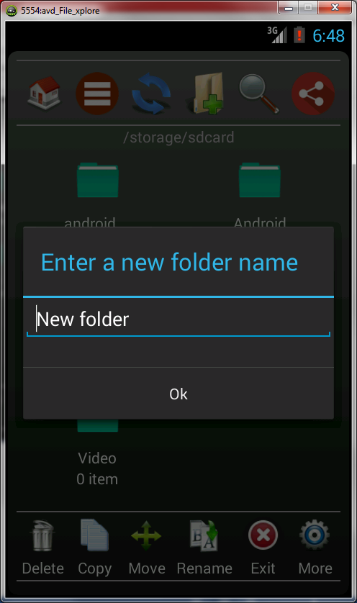 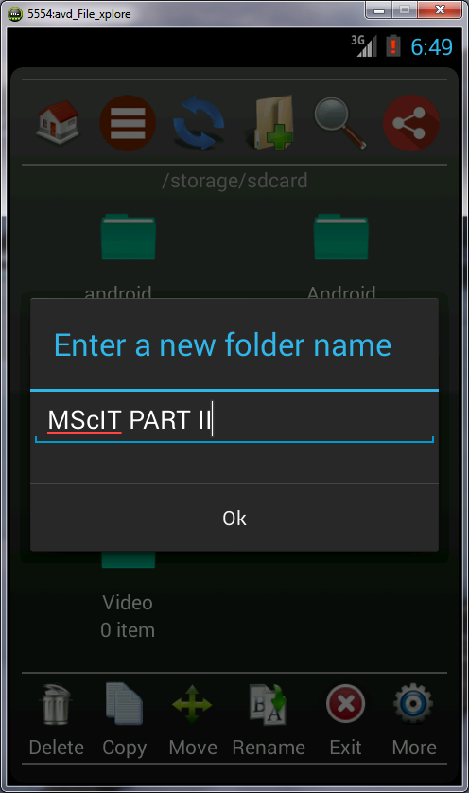

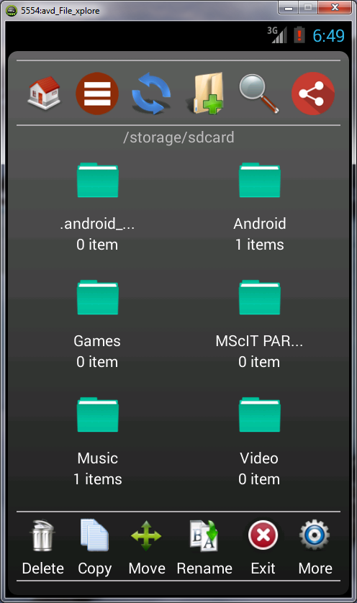

SHARE page

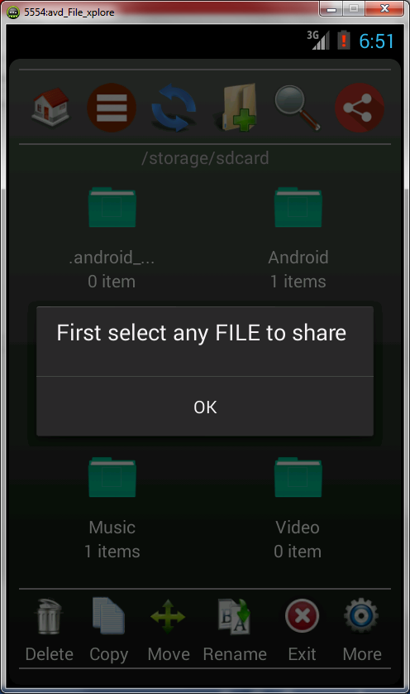

DELETE page

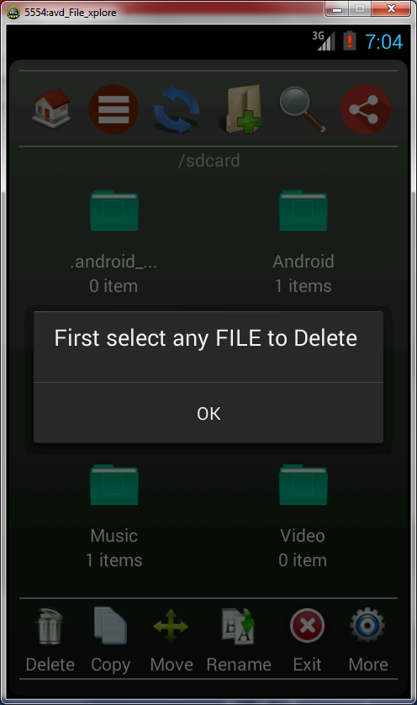 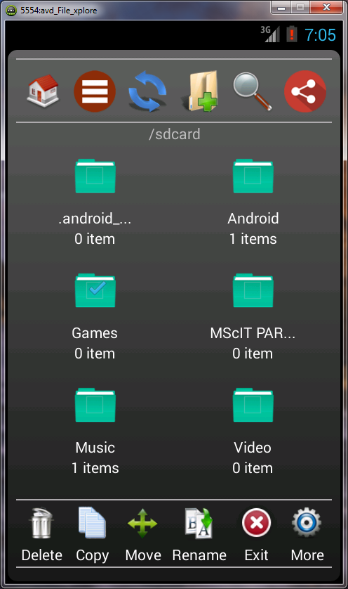

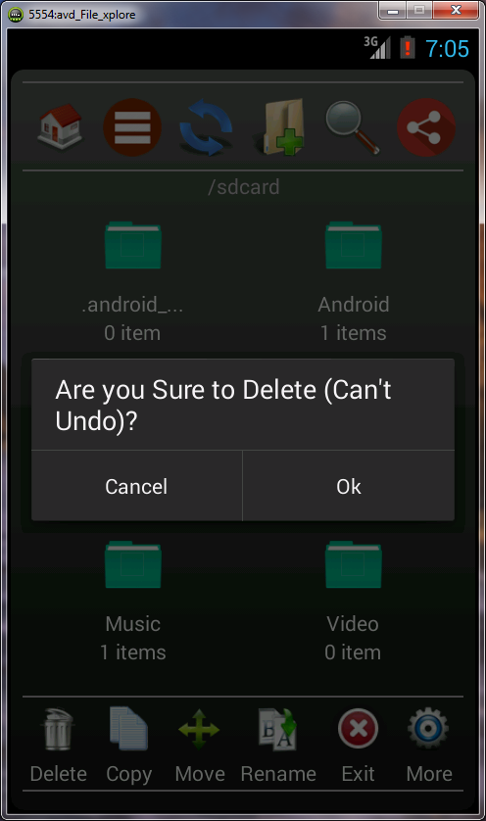 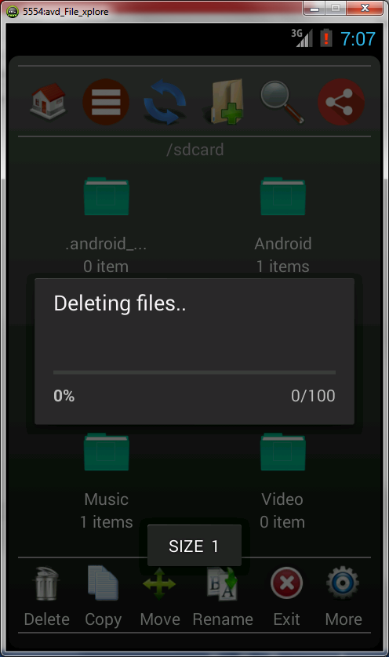

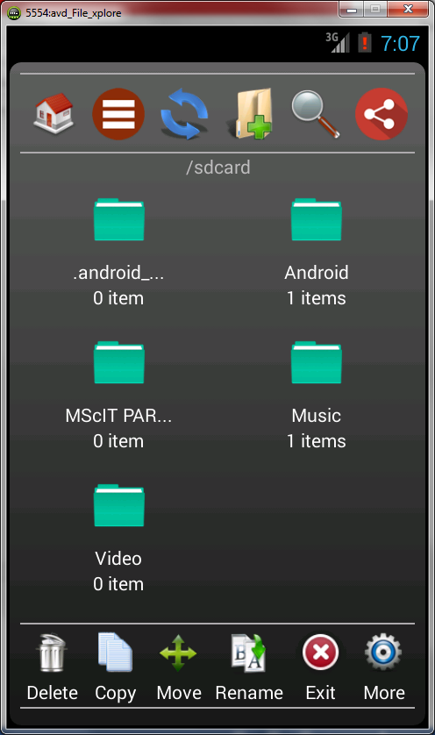

COPY page

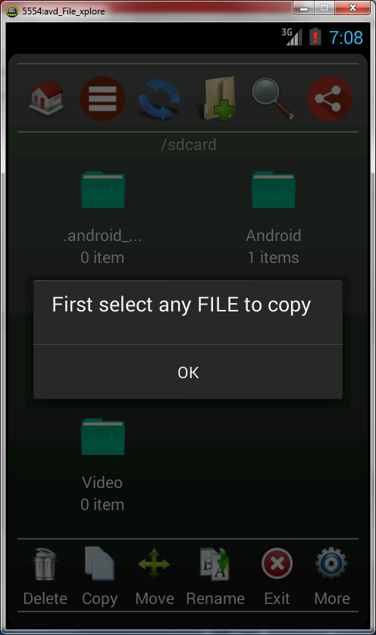 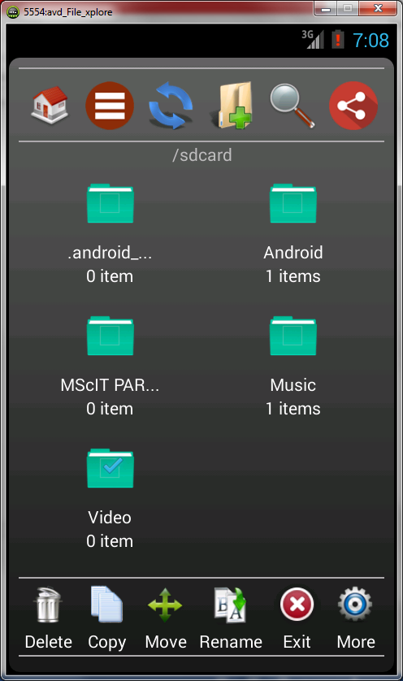

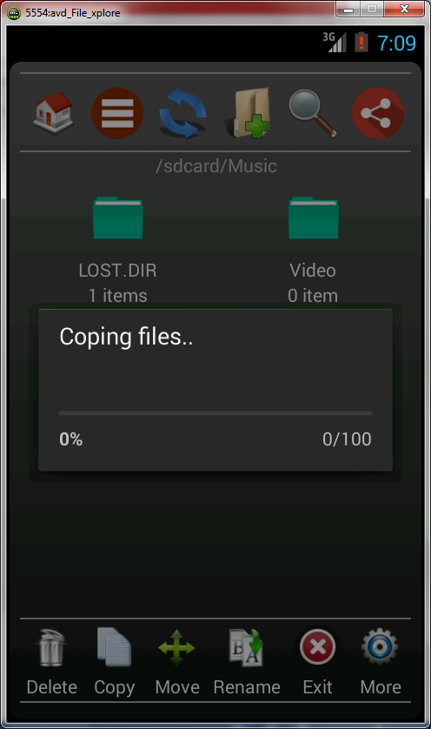 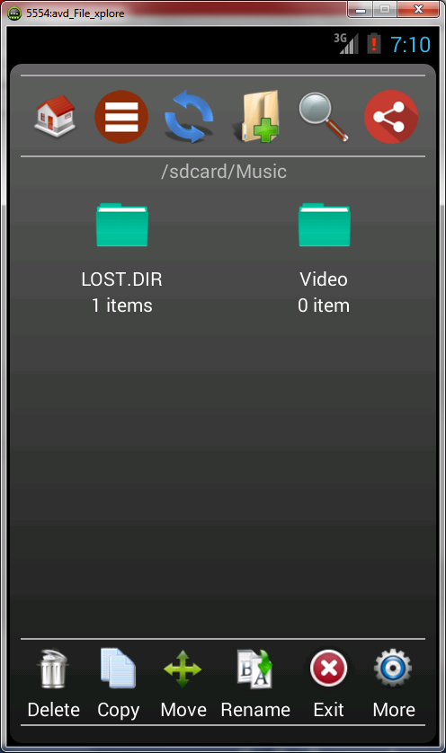

MOVE page

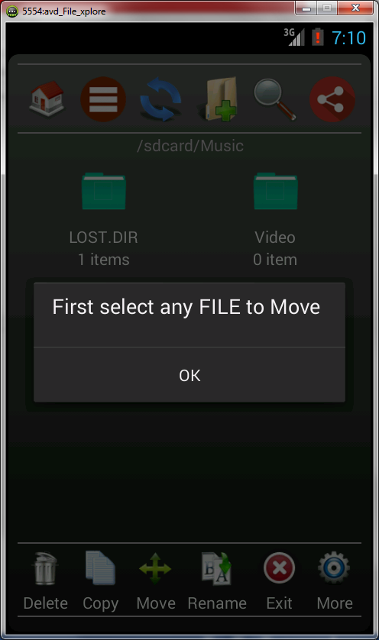 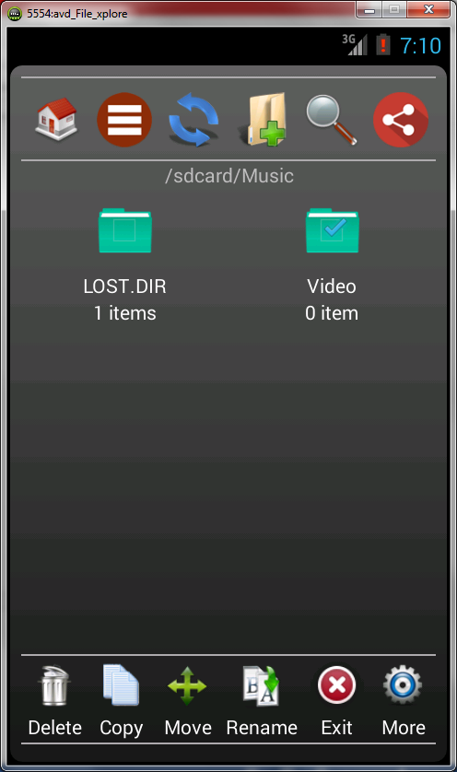

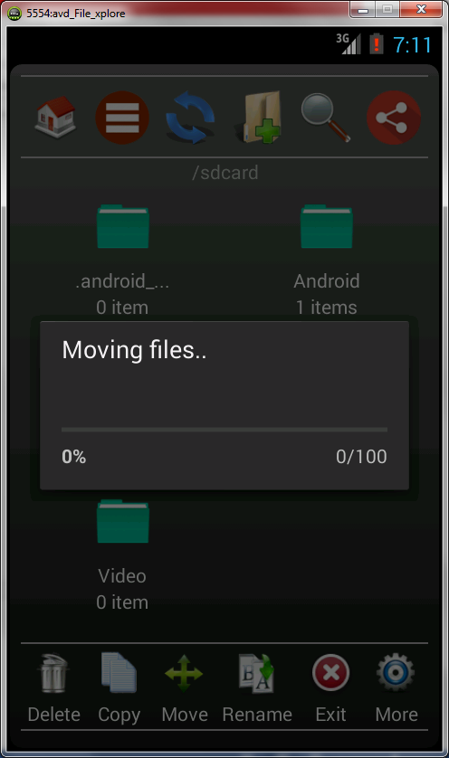 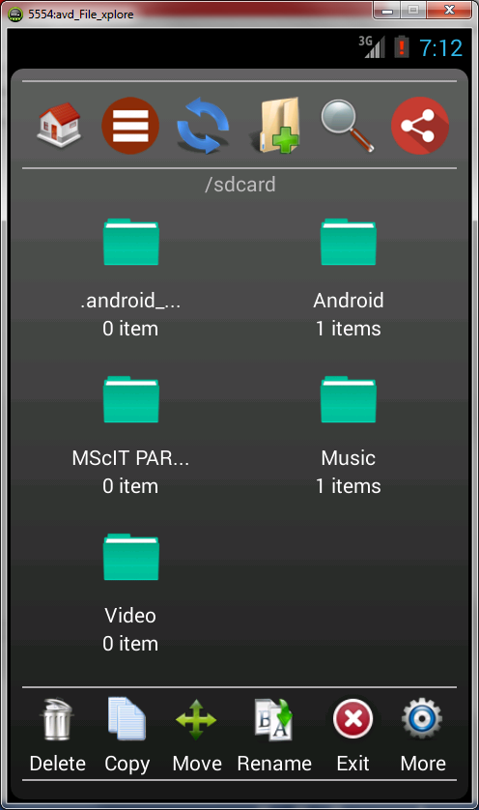

RENAME page

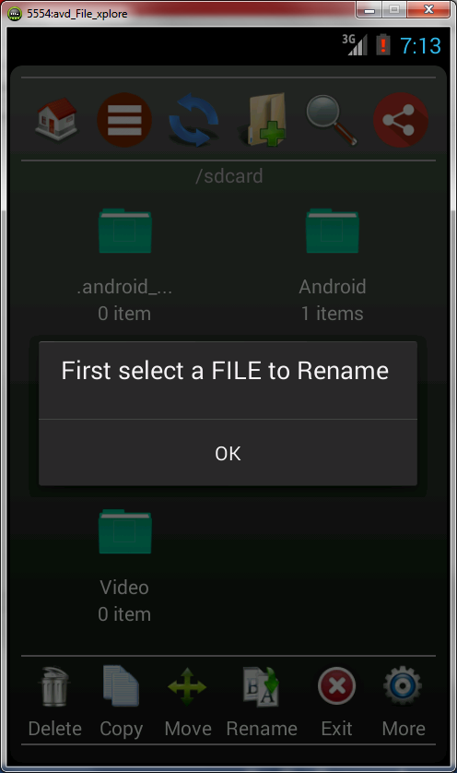 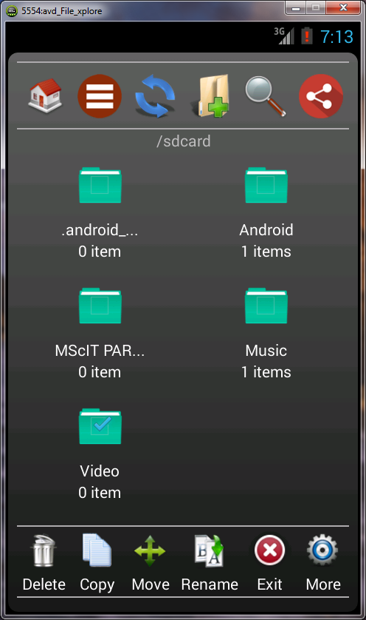

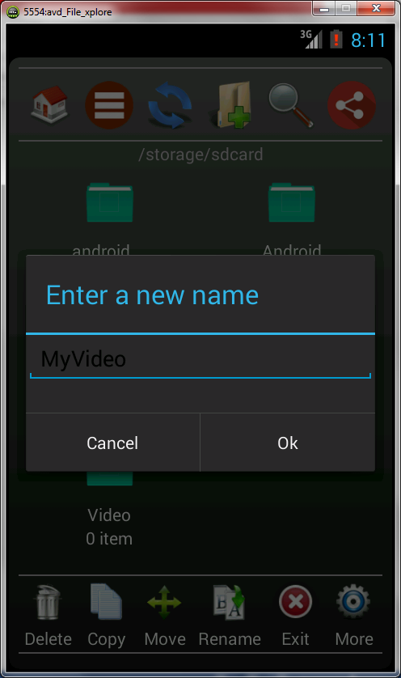 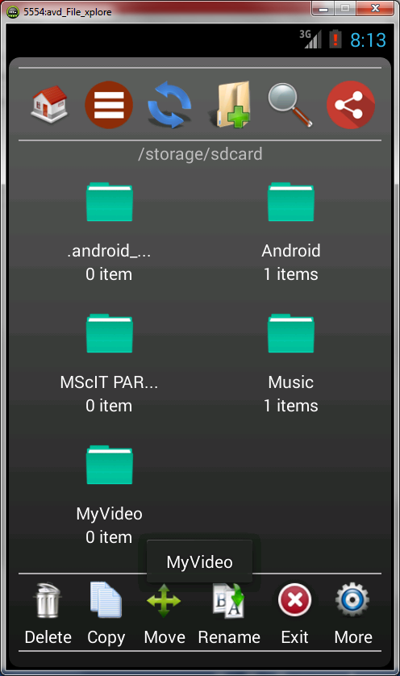

EXIT page

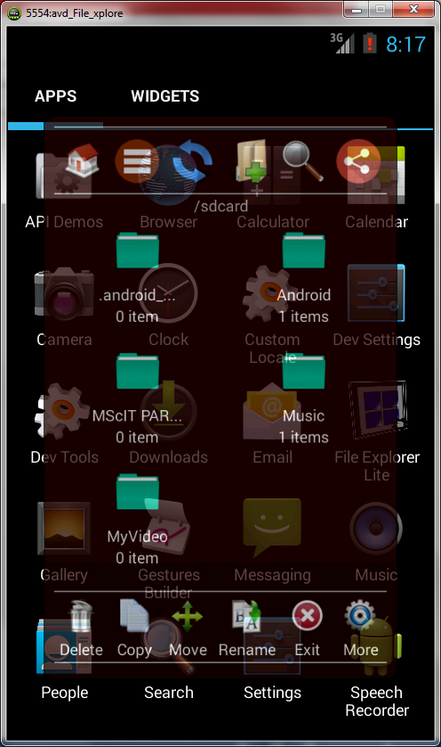

MORE page

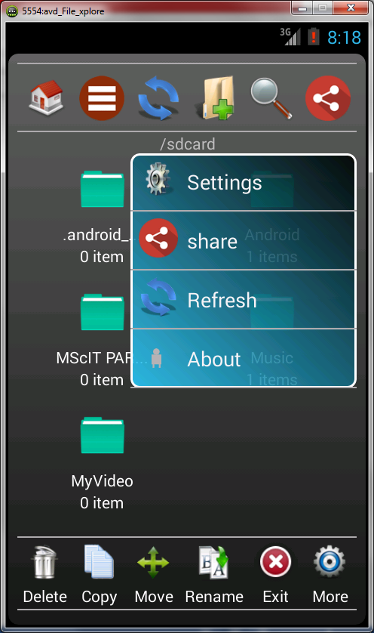

MORE > SETTING

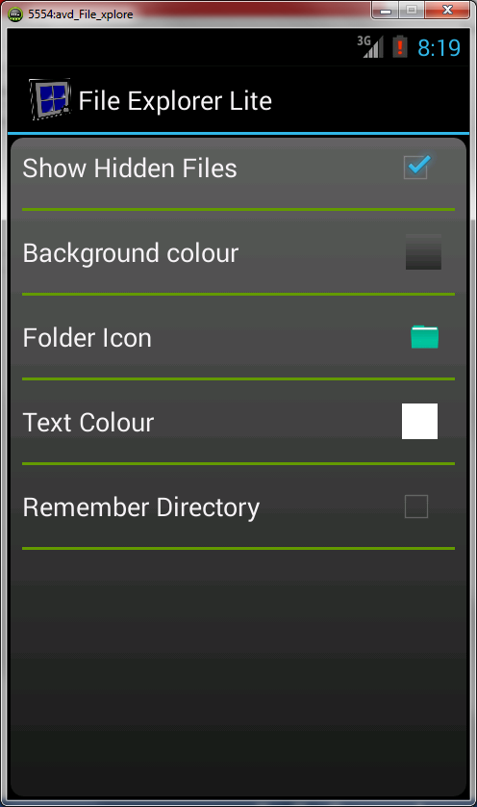

MORE > SETTING > Background Color

Before After selecting ‘Gradient Blue Light’

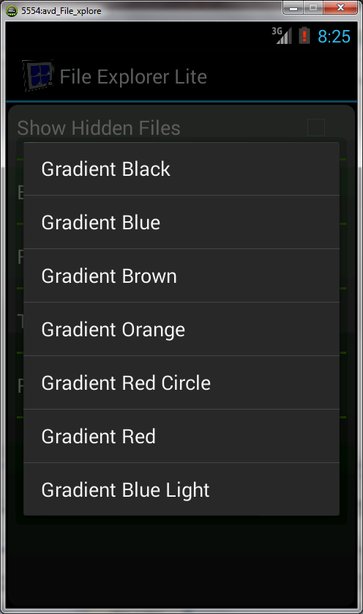 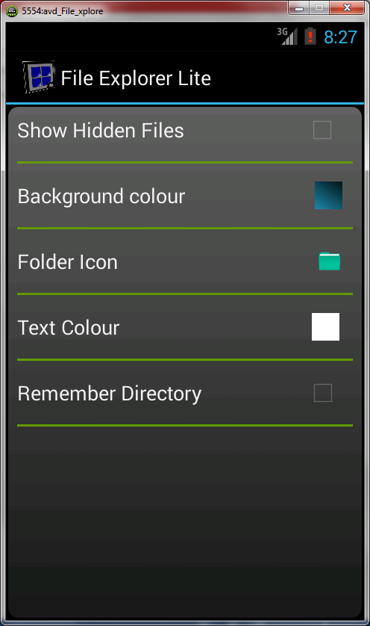

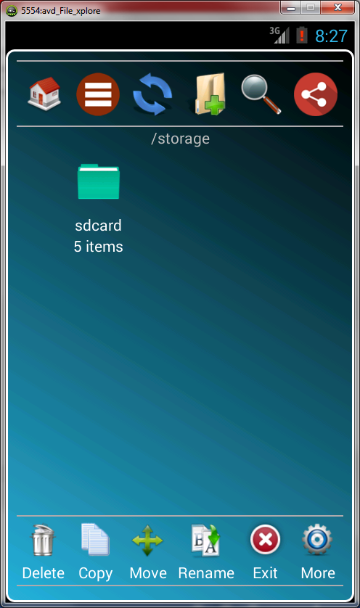

MORE > SETTING > Folder Icon

Before After selecting color ‘Black-2’

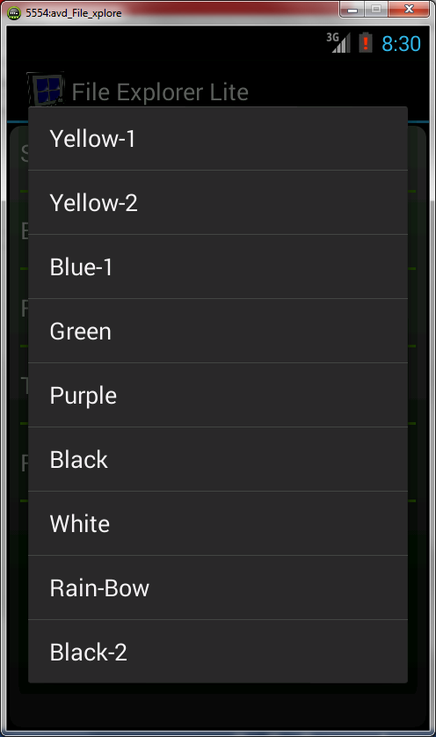 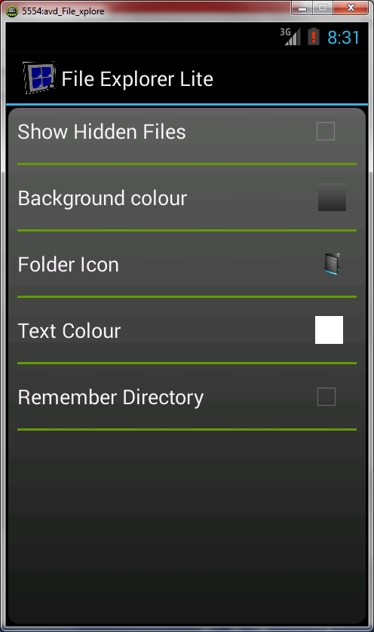

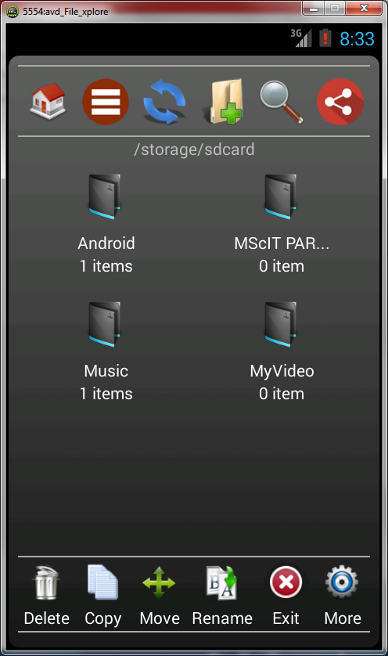

MORE > SETTING > Text Color

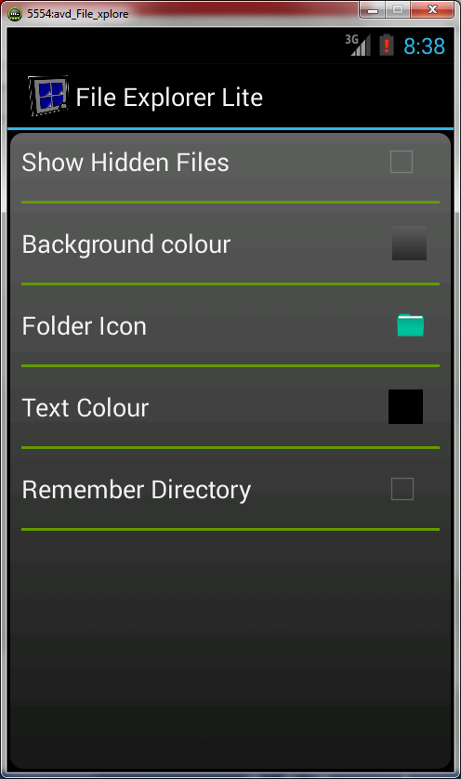 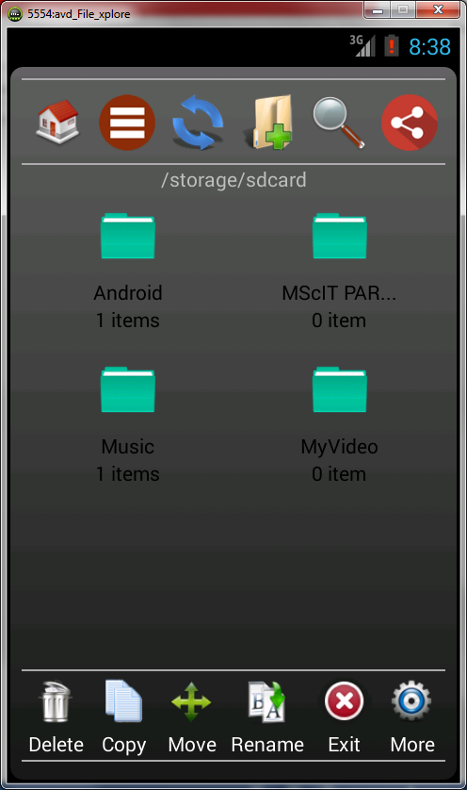

FOLDER PROPERTIES PAGE

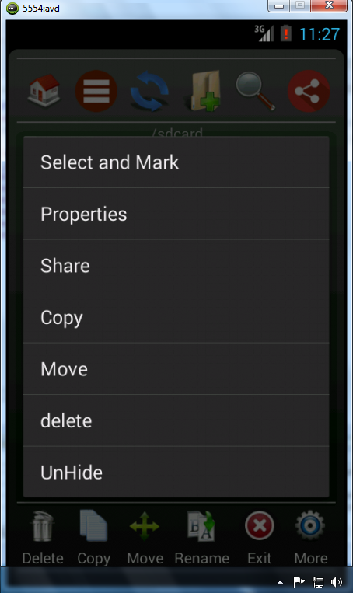

**PROCESSES INVOLVED**

**SOFTWARE DEVELOPMENT LIFE CYCLE**

Systems Development Life Cycle (SDLC) is a logical process used by a systems analyst to develop an information system, including requirements, validation, training, and user (stakeholder) ownership.

Any SDLC should result in a high quality system that meets or exceeds customer expectations, reaches completion within time and cost estimates, works effectively and efficiently in the current and planned Information Technology infrastructure, and is inexpensive to maintain and cost-effective to enhance.

Systems Development Life Cycle (SDLC) adheres to important phases that are essential for developers, such as planning, analysis, design, and implementation.

SOFTWARE DEVELOPMENT LIFE CYCLE

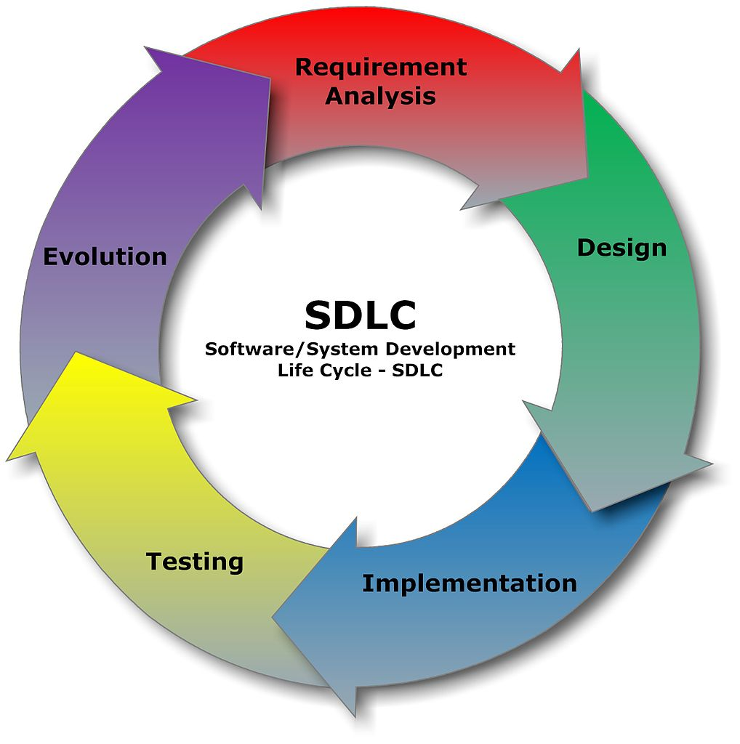

**METHODOLOGY ADOPTED**

**ITERATIVE WATERFALL MODEL**

The waterfall model is a sequential software development process, in which progress is seen as flowing steadily downwards (like a waterfall) through the phases of Conception, Initiation, Analysis, Design, Construction, Testing and Maintenance.

**ITERATIVE WATERFALL MODEL PROCESS**

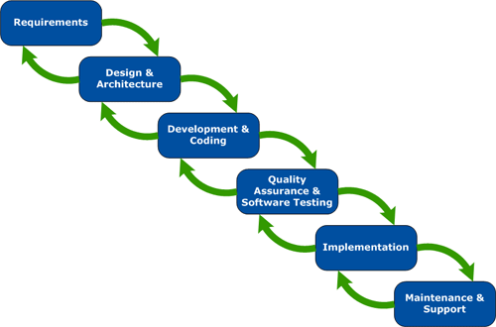

**PHASES IN WATERFALL MODEL**

**REQUIREMENT**

All possible requirements of the system to be developed are captured in this phase. Requirements are set of functionalities and constraints that the end-user (who will be using the system) expects from the system. The requirements are gathered from the end-user by consultation.

**ANALYSIS**

All requirements gathered from the end-user are analyzed for their validity and the possibility of incorporating the requirements in the system to be development. Once the analysis is done the development team provides a document that holds the different specific recommendations for the candidate system. It also consists of personnel assignments, costs of the system, project schedule and target dates.

**DESIGN**

System Design helps in specifying hardware and system requirements and also helps in defining overall system architecture. After designing part a software development model is created. Analysis and Design are very important in the whole development cycle process. In this phase, the logical system of the product is developed.

**CODING**

On receiving system design documents, the work is divided in modules/units and actual coding is started. The system is first developed in small programs called units, which are then integrated. In Code Generation phase, the design must be decoded into a machine-readable form. If the design of software product is done in a detailed manner, code generation can be achieved without much complication. For generation of code, Programming tools like Compilers, Interpreters, and Debuggers are used.

**TESTING**

After code generation phase the software program testing begins. Different testing methods are available to detect the bugs that were committed during the previous phases. A number of testing tools and methods are already available for testing purpose.

**ACCEPTANCE**

The acceptance phase is an important part at the end of each delivery cycle. After successfully testing the software, it is delivered to the customer. Any concerns about the project will be quickly dealt with and will have the confidence in knowing that our project is moving forward in the way candidate wish. Software Engineers are dedicated to provide with a project that exceeds end-users expectations using process that will not waste their money..

**ADVANTAGES:-**

1. The key advantage is that this approach allows developers to break down the task of developing a system into a series of smaller tasks. These can then be completed separately, evaluated, and subsequently re-worked until the system performs adequately.
2. Knowledge gained from developing and testing these small sections can then be incorporated back into the development of other parts of the project.

**DISADVANTAGES:-**

1. Unlike the Waterfall model, where strict documentation of the entire development process is a design requirement, many iterative approaches favor lighter documentation.

2. This can reduce project overheads. However, there is a risk that under-documentation

could lead to needless duplication of effort, and time wasted developing within a task with a poorly-defined scope

.

**SYSTEM IMPLEMENTATION & DETAILS OF HARDWARE and SOFTWARE USED**

**System Implementation**

The fourth phase of the systems development life cycle, in which the information system is programmed, tested, installed, and supported. It is use to put the utility into action.

**Implementation** is the realization of an application, or execution of a plan, idea, model, design, specification, standard, algorithm, or policy.

An implementation is a realization of a technical specification or algorithm as a program, software component, or other computer system through programming and deployment. Many implementations may exist for a given specification or standard. For example, web browsers contain implementations of World Wide Web Consortium recommended specifications, and software development tools contain implementations of programming languages.

Implementation is the state in the project where theoretical design turned into working system. The most crucial stage is achieving a new successful system and giving confidence in new system that it will work efficiently and effectively. The system is implemented only after thorough checking is done and it is found working according to the specifications.

The major implementation procedure are:-

1. **Test plans**

The implementation of a computer based system requires that the test data can be

Prepared and the system and its elements be tested in a structured manner.

**2. Training**

The purpose of training is to ensure that all the personnel who are to be associated with the computer based system possesses necessary knowledge skills.

**3. Equipment installation**

Equipment vendors can provide specifications for equipment installation. They usually work with projects equipment installation team is planning for adequate space, power and light, and a suitable environment. After a suitable site has been completed, the computer equipment can be installed.

**4. Conversion**

It is the processes of performing all of the operations that result directly in turnover of the new system to the user. Conversion has two parts:-

1. The creation of a conversion plan at the start of the development phase and the implementation of the plan throughout the development phase.

2. The creation of a system change over plan at the end of the development phase and the implementation of the plan at the beginning of operation phase.

SYSTEM REQUIREMENT:

**SOFTWARE**

* Operating system- window Xp/7
* Java
* Eclipse
* Android SDK

**DEVICE HARDWARE**

Min. Processor : ARM architecture, 200 MHz,

Operating System : Android

RAM : 128 MB, 512 recommended

Flash Memory : 256

Display : 3.5 inches or more screen size

**SYSTEM HARDWARE**

Processor : Intel Pentium i3 or higher

Processor speed : 2.3 GHz

Hard Disk Space : 160 GB (min.)

Ram Memory : 2 GB DDR3

Device : Android supported device

**SYSTEM MAINTENANCE and EVALUATION**

**SYSTEM MAINTENANCE**

The results obtained from the evaluation process help the organization to determine whether its information systems are effective and efficient or otherwise. The process of monitoring, evaluating, and modifying of existing information systems to make required or desirable improvements may be termed as System Maintenance.

System maintenance is an ongoing activity, which covers a wide variety of activities, including removing program and design errors, updating documentation and test data and updating user support.

The fifth (and final) phase of the systems development life cycle, in which an information system is systematically repaired and/or improved.

ITS DIFFERENT TYPES:-

For the purpose of convenience, maintenance may be categorized into three classes, namely:

**i) Corrective. ii) Adaptive. iii) Perfective.**

i) **Corrective Maintenance**: - This type of maintenance implies removing errors in a program, which might have crept in the system due to faulty design or wrong assumptions. Thus, in corrective maintenance, processing or performance failures are repaired.

ii) **Adaptive Maintenance**: - In adaptive maintenance, program functions are changed to enable the information system to satisfy the information needs of the user.

iii) **Perfective Maintenance**: - Perfective maintenance means adding new programs or modifying the existing programs to enhance the performance of the information system. This type of maintenance undertaken to respond to user’s additional needs which may be due to the changes within or outside of the organization. Outside changes are primarily environmental changes, which may in the absence of system maintenance; render the information system ineffective and inefficient.

These environmental changes include:-

Changes in database tables while updating the application for new update. Changes in look and feel such as forms of the application.

**EVALUATION**

Evaluation is a systematic determination of a subject's merit, worth and significance, using criteria governed by a set of standards. It can assist an organization to assess any aim, realizable concept/proposal, or any alternative, to help in decision-making; or to ascertain the degree of achievement or value in regard to the aim and objectives and results of any such action that has been completed. The primary purpose of evaluation, in addition to gaining insight into prior or existing initiatives, is to enable reflection and assist in the identification of future change.

Evaluation is often used to characterize and appraise subjects of interest in a wide range of human enterprises, including the arts, criminal justice, foundations, non-profit organizations, government, health care, and other human services.

Evaluation is the structured interpretation and giving of meaning to predict or actual impacts of proposals or results. It looks at original objectives, and at what is either predicted or what was accomplished and how it was accomplished. So evaluation can be **formative** that is taking place during the development of a concept or proposal, project or organization, with the intention of improving the value or effectiveness of the proposal, project, or organization. It can also be **summative**, drawing lessons from a completed action or project or an organization at a later point in time or circumstance.

**CODES**

**JAVA CODES**

Code for About Page:

package com.rv.fileexp.lite;

import com.dark.explorer.lite.rv.R;

import com.rv.fileexp.lite.a.Slsect_main_gridview_bg;

import android.os.Bundle;

import android.app.Activity;

import android.content.SharedPreferences;

import android.view.Menu;

import android.view.Window;

import android.widget.RelativeLayout;

public class AboutyActivity extends Activity {

@Override

protected void onCreate(Bundle savedInstanceState) {

super.onCreate(savedInstanceState);

this.requestWindowFeature(Window.FEATURE_NO_TITLE);

setContentView(R.layout.activity_about_activity);

SharedPreferences setting = getSharedPreferences("settings", 0);

String bg_colour_main = setting.getString("bg_colour_main", "g_red");

RelativeLayout r_gradient = (RelativeLayout) findViewById(R.id.relative_layout_about);

Slsect_main_gridview_bg obb = new Slsect_main_gridview_bg();

int nn = obb.get_main_linear_layout_bg(bg_colour_main);

r_gradient.setBackgroundDrawable(getResources().getDrawable(nn)); //gradient all effect work

}

@Override

public boolean onCreateOptionsMenu(Menu menu) {

// Inflate the menu; this adds items to the action bar if it is present.

getMenuInflater().inflate(R.menu.abouty, menu);

return true;

}

@Override

protected void onPause() {

// TODO Auto-generated method stub

super.onPause();

this.finish();

}

}

**Code for Copy, Move, Delete:**

package com.rv.fileexp.lite;

import java.io.File;

import java.io.FileInputStream;

import java.io.FileNotFoundException;

import java.io.FileOutputStream;

import java.io.IOException;

import java.io.InputStream;

import java.io.OutputStream;

import java.nio.channels.FileChannel;

import android.os.Environment;

public class Move_Copy_Delete {

// your sd card

String sdCard = Environment.getExternalStorageDirectory().toString();

//Toast.makeText(getBaseContext(),""+sdCard, 10).show();

// the file to be moved or copied

File sourceLocation = new File (sdCard + "/sample.txt");

// make sure your target location folder exists!

File targetLocation = new File (sdCard +"/MyNewFolder/sample.txt");

// just to take note of the location sources

//Log.v(TAG,"sourceLocation: " + sourceLocation);

// Log.v(TAG,"targetLocation: " + targetLocation);

//////////////////////////////////////// COPY ///////////////////////////////////////////////

public static void copyFolder(File src, File dest) throws IOException{

if(src.isDirectory()){

//if directory not exists, create it

if(!dest.exists()){ dest.mkdir(); System.out.println("Directory copied from " + src + " to " + dest) }

// /list all the directory contents

String files[] = src.list();

for (String file : files) {

//construct the src and dest file structure

File srcFile = new File(src, file)

File destFile = new File(dest, file);

//recursive copy

copyFolder(srcFile,destFile);

}

}else{

//if file, then copy it

//Use bytes stream to support all file types

InputStream in = new FileInputStream(src);

OutputStream out = new FileOutputStream(dest);

byte[] buffer = new byte[1024];

int length;

//copy the file content in bytes

while ((length = in.read(buffer)) > 0){

out.write(buffer, 0, length);

}

in.close();

out.close();

System.out.println("File copied from " + src + " to " + dest);

}

}

//////////////////////////////////////// MOVE /////////////////////////////////////////////////////////////

public boolean movefile(File sourceLocation,File targetLocation)

{

// 1 = move the file, 2 = copy the file

int actionChoice = 1;

// moving the file to another directory

if(actionChoice==1){

if(sourceLocation.renameTo(targetLocation)){

// Log.v(TAG, "Move file successful.");

return true;

}else{

// Log.v(TAG, "Move file failed.");

return false;

}

}

return false;

}

/////////////////////////////////////////// DELETE /////////////////////////////////////////

public boolean delete_file(File file_del){

boolean status;

if(file_del.isDirectory())

for(File child : file_del.listFiles())

delete_file(child);

status = file_del.delete();

// File file = new File(path);

// if(file.isDirectory())

// String[] children = file.list();

// for(int i = 0; i<children.length;i++){

// new File(file , children[i]).delete();

// return true;

// }

// }else{

// boolean deleted = file.delete();

// return deleted;

//

// }

// return false; return status; }}

**Code for Video Player:**

package com.rv.fileexp.lite.video.player;

import java.util.ResourceBundle.Control;

import com.dark.explorer.lite.rv.*;

import android.app.Activity;

import android.os.Bundle;

import android.util.DisplayMetrics;

import android.view.SurfaceView;

import android.view.Window;

import android.view.WindowManager;

import android.widget.MediaController;

import android.widget.Toast;

import android.widget.VideoView;

public class VideoPlayerActivity extends Activity {

VideoView video_player_view;

DisplayMetrics dm;

SurfaceView sur_View;

MediaController media_Controller;

String spath;

/** Called when the activity is first created. */

@Override

public void onCreate(Bundle savedInstanceState) {

super.onCreate(savedInstanceState);

this.requestWindowFeature(Window.FEATURE_NO_TITLE);

this.getWindow().setFlags(WindowManager.LayoutParams.FLAG_FULLSCREEN,WindowManager.LayoutParams.FLAG_FULLSCREEN);

setContentView(R.layout.activity_video_player);

Bundle extras = getIntent().getExtras();

if(extras != null){

spath = extras.getString("image_native_video");

}

getInit();

}

public void getInit() {

video_player_view = (VideoView) findViewById(R.id.video_player_view);

media_Controller = new MediaController(this);

dm = new DisplayMetrics();

this.getWindowManager().getDefaultDisplay().getMetrics(dm);

int height = dm.heightPixels;

int width = dm.widthPixels;

// int width =450;

// int height =800;

video_player_view.setMinimumWidth(width);

video_player_view.setMinimumHeight(height);

video_player_view.setMediaController(media_Controller);

try{

Toast.makeText(getApplicationContext(), spath, Toast.LENGTH_LONG).show();

video_player_view.setVideoPath(spath);

video_player_view.start();

}catch(Exception exc){}

}

}

**XML CODES**

**Xml code for AboutActivity.xml:**

<RelativeLayout xmlns:android=*"http://schemas.android.com/apk/res/android"*

xmlns:tools=*"http://schemas.android.com/tools"*

android:id=*"@+id/relative_layout_about"*

android:layout_width=*"wrap_content"*

android:layout_height=*"match_parent"*

android:paddingBottom=*"@dimen/activity_vertical_margin"*

android:paddingLeft=*"@dimen/activity_horizontal_margin"*

android:paddingRight=*"@dimen/activity_horizontal_margin"*

android:paddingTop=*"@dimen/activity_vertical_margin"*

android:scrollbars=*"vertical"*

tools:context=*".AboutyActivity"* >

<TextView

android:id=*"@+id/tpath"*

android:layout_width=*"match_parent"*

android:layout_height=*"wrap_content"*

android:layout_alignParentTop=*"true"*

android:layout_centerHorizontal=*"true"*

android:layout_marginTop=*"44dp"*

android:gravity=*"center_horizontal"*

android:text=*"SOFTWARE DEVELOPED BY"*

android:textColor=*"#FF2400"* />

<TextView

android:id=*"@+id/textView2"*

android:layout_width=*"match_parent"*

android:layout_height=*"wrap_content"*

android:layout_below=*"@+id/tpath"*

android:layout_centerHorizontal=*"true"*

android:layout_marginTop=*"47dp"*

android:text=*"RAJEEV n VISHAL"*

android:textAppearance=*"?android:attr/textAppearanceLarge"*

android:gravity=*"center_horizontal"*

android:textColor=*"#adff2f"* />

<TextView

android:id=*"@+id/textView5"*

android:layout_width=*"match_parent"*

android:layout_height=*"wrap_content"*

android:layout_below=*"@+id/textView3"*

android:layout_centerHorizontal=*"true"*

android:gravity=*"center_horizontal"*

android:text=*"rajeevs519@gmail.com"*

android:textColor=*"#FF2400"* />

<TextView

android:id=*"@+id/textView6"*

android:layout_width=*"match_parent"*

android:layout_height=*"wrap_content"*

android:layout_alignLeft=*"@+id/textView3"*

android:layout_below=*"@+id/textView4"*

android:layout_marginTop=*"56dp"*

android:gravity=*"center_horizontal"*

android:text=*"2015"*

android:textColor=*"#FF2400"*

android:textAppearance=*"?android:attr/textAppearanceLarge"* />

<TextView

android:id=*"@+id/textView4"*

android:layout_width=*"match_parent"*

android:layout_height=*"wrap_content"*

android:layout_alignLeft=*"@+id/textView5"*

android:layout_below=*"@+id/textView5"*

android:layout_marginTop=*"25dp"*

android:gravity=*"center_horizontal"*

android:text=*"[Send your feedback through Email only, it is the only way to reach us. Your feedback will improve future update of this software]"*

android:textColor=*"#FF2400"* />

<TextView

android:id=*"@+id/textView3"*

android:layout_width=*"match_parent"*

android:layout_height=*"wrap_content"*

android:layout_alignLeft=*"@+id/textView5"*

android:layout_below=*"@+id/textView2"*

android:gravity=*"center_horizontal"*

android:text=*"S.M.SHETTY,POWAI"*

android:textColor=*"#F0E68C"*/>

<TextView

android:id=*"@+id/textView1"*

android:layout_width=*"wrap_content"*

android:layout_height=*"wrap_content"*

android:layout_below=*"@+id/textView5"*

android:layout_centerHorizontal=*"true"*

android:text=*"vishalmaurya786@gmail.com"*

android:textColor=*"#FF2400"* />

</RelativeLayout>

Xml code for Video Player:

<?xml version=*"1.0"* encoding=*"utf-8"*?>

<RelativeLayout xmlns:android=*"http://schemas.android.com/apk/res/android"*

android:layout_width=*"match_parent"*

android:layout_height=*"fill_parent"* >

<VideoView

android:id=*"@+id/video_player_view"*

android:layout_alignParentTop=*"true"*

android:layout_alignParentLeft=*"true"*

android:layout_alignParentRight=*"true"*

android:layout_alignParentBottom=*"true"*

android:layout_width=*"fill_parent"*

android:layout_height=*"fill_parent"* />

</RelativeLayout>

**Xml Code for AndroidManifest.xml**

<?xml version=*"1.0"* encoding=*"utf-8"*?>

<manifest xmlns:android=*"http://schemas.android.com/apk/res/android"*

package=*"com.dark.explorer.lite.rv"*

android:versionCode=*"10"*

android:versionName=*"3.1.56"* >

<uses-sdk

android:minSdkVersion=*"11"*

android:targetSdkVersion=*"19"* />

<uses-permission android:name=*"android.permission.WRITE_EXTERNAL_STORAGE"* />

<uses-permission android:name=*"android.permission.READ_EXTERNAL_STORAGE"* />

<uses-permission android:name=*"android.permission.MOUNT_FORMAT_FILESYSTEMS"*/>

<uses-permission android:name=*"android.permission.MOUNT_UNMOUNT_FILESYSTEMS"*/>

<application

android:allowBackup=*"true"*

android:icon=*"@drawable/ic_launcher"*

android:label=*"@string/app_name"* >

<!-- android:theme="@style/AppTheme" -->

<activity

android:name=*"com.rv.fileexp.lite.ActivityListdirectry"*

android:label=*"@string/title_activity_listdirectry"* >

<intent-filter>

<action android:name=*"android.intent.action.MAIN"* />

<category android:name=*"android.intent.category.LAUNCHER"* />

</intent-filter>

</activity>

<activity

android:name=*"com.rv.fileexp.lite.AboutyActivity"*

android:label=*"@string/title_activity_listdirectry"* >

<intent-filter>

<action android:name=*"com.ebin.fileexp.lite.AboutyActivity"* />

<category android:name=*"android.intent.category.DEFAULT"* />

</intent-filter>

</activity>

<activity

android:name=*"com.rv.fileexp.lite.image.viewer.FullScreenViewActivity"*

android:label=*"@string/title_activity_listdirectry"* >

<intent-filter>

<action android:name=*"com.image.viewer.FullScreenViewActivity"* />

<category android:name=*"android.intent.category.DEFAULT"* />

</intent-filter>

</activity>

<activity

android:name=*"com.rv.fileexp.lite.musicplayer.AndroidBuildingMusicPlayerActivity"*

android:label=*"@string/title_activity_listdirectry"* >

<intent-filter>

<action android:name=*"musicplayer.AndroidBuildingMusicPlayerActivity"* />

<category android:name=*"android.intent.category.DEFAULT"* />

</intent-filter>

</activity>

<activity

android:name=*"com.rv.fileexp.lite.musicplayer.PlayListActivity"*

android:label=*"@string/title_activity_listdirectry"* >

<intent-filter>

<action android:name=*"musicplayer.PlayListActivity"* />

<category android:name=*"android.intent.category.DEFAULT"* />

</intent-filter>

</activity>

<activity

android:name=*"com.dark.explorer.lite.ebinjoy.AboutyActivity"*

android:label=*"@string/title_activity_abouty"* >

</activity>

<activity

android:name=*"com.rv.fileexp.lite.video.player.VideoPlayerActivity"*

android:label=*"@string/app_name"*

android:screenOrientation=*"landscape"* >

<intent-filter>

<action android:name=*"com.ebin.fileexp.lite.vedio.player.VideoPlayerActivity"* />

<category android:name=*"android.intent.category.DEFAULT"* />

</intent-filter>

</activity>

<activity

android:name=*"com.rv.fileexp.lite.a.Activity_fileexp_settings"*

android:label=*"@string/app_name"*>

<intent-filter>

<action android:name=*"com.ebin.fileexp.lite.a.Activity_fileexp_settings"* />

<category android:name=*"android.intent.category.DEFAULT"* />

</intent-filter>

</activity>

</application>

</manifest>

**Xml code for Strings.xml:**

<?xml version=*"1.0"* encoding=*"utf-8"*?>

<resources>

<string name=*"app_name"*>FILE X-PLORE</string>

<string name=*"action_settings"*>Settings</string>

<string name=*"hello_world"*>Hello world!</string>

<string name=*"title_activity_listdirectry"*>FILE X-PLORE</string>

<string name=*"title_activity_word"*>Word</string>

<string name=*"title_activity_abouty"*>AboutyActivity</string>

<string name=*"title_activity_activity_fileexp_settings"*>Activity_fileexp_settings</string>

<string name=*"email1"*>vishalmaurya786@gmail.com</string>

</resources>

**TESTING METHODOLOGY**

**Introduction**

The testing of the software is the means of assessing or measuring the software to determine its quality. The area of testing is one of the key process areas in ensuring the quality of software.

**Objective of testing**

Testing is done with one primary objective to ensure the quality of the software before live operations. Testing should be in-depth and not superficial. The real goal of testing should be to find error.

**Test Plan**

A test plan is a general document for the entire project that defines the scope, approach to be taken, and the schedule of testing as well as identifies the test items for the entire testing process and the personnel responsible for the different activities of testing.

The test planning can be done well before the actual testing commences can be done in parallel in the design and coding phase.

The input for the test plan is:

1. Project Plan

2. Requirement Document

3. System Design Document

The project plan is needed to make sure that the test plan can be consistent with the overall plan for the project and the testing schedule matches that of the project plan. The requirement document and the design document are the basic documents used for selecting the test unit and deciding the approaches to be used during testing.

A test plan should contain the following:

1. Test Unit Specification.

2. Feature to be tested.

3. Approach for testing.

**a. Test unit Specification**

A test unit is a set of one or more modules, together which associated data that are from single computer program that are the object of testing.

A test unit can occur at any level and can contain from a single module to entire system.

**b. Features to be tested**

All functional features specified in the requirement document will be tested. The features to be tested are:

* Proper Connection establishment with application.

➢ Proper transmission of data.

➢ Proper and correct retrieval of data.

➢ Proper start-up of Application.

➢ Interactive and friendly user interface.

➢ proper displaying linking of interface.

➢ Amount of time taken for connection and retrieval of data between User and application.

**c. Approach for testing**

There approaches to testing are:

1. White Box Testing

2. Black Box Testing

3. Unit testing

4. Integration testing

5. System testing

**White Box Testing:**

White box testing strategy deals with the internal logic and structure of the code. White box testing is also called as glass, structural, open box or clears box testing. In order to implement white box testing, the tester has to deal with the code and hence is needed to possess knowledge of coding and logic i.e. internal working of the code. White box test also needs the tester to look into the code and find out which unit/statement/chunk of the code is malfunctioning.

**Advantages are:**

i) As the knowledge of internal coding structure is prerequisite, it becomes very easy to find out which type of input/data can help in testing the application effectively.

ii) The other advantage of white box testing is that it helps in optimizing the code. iii) It helps in removing the extra lines of code, which can bring in hidden defects

**Disadvantages are:**

i) As knowledge of code and internal structure is a prerequisite, a skilled tester is needed to carry out this type of testing, which increases the cost.

ii) And it is nearly impossible to look into every bit of code to find out hidden errors, which may create problems, resulting in failure of the application.

**Black Box Testing:**

Black Box Testing is not a type of testing; it instead is a testing strategy, which does not need any knowledge of internal design or code etc. As the name "black box" suggests, no knowledge of internal logic or code structure is required. The types of testing under this strategy are totally based/focused on the testing for requirements and functionality of the work product/software application. Black box testing is sometimes also called as "Opaque Testing", "Functional/Behavioral Testing" and "Closed Box Testing".

The base of the Black box testing strategy lies in the selection of appropriate data as per functionality and testing it against the functional specifications in order to check for normal and abnormal behavior of the system.

**Unit Testing:**

Unit testing focuses on verification the smallest unit of s/w design module. Using the procedural design description as a guide, important control paths are tested to uncover errors within the boundary of the module.

For text to speech module we are checking following things.

* Number of arguments passed to functions to call this module is equal to number of parameters.
* OPEN/CLOSE statement are correct
* Checking for buffer size.
* Applied module for different text files and it functions correctly.

**Integration testing:**

Integration testing (sometimes called Integration and Testing, abbreviated "I&T") is the phase in software testing in which individual software modules are combined and tested as a group. It occurs after unit testing and before validation testing. Integration testing takes as its input modules that have been unit tested, groups them in larger aggregates, applies tests defined in an integration test plan to those aggregates, and delivers as its output the integrated system ready for system testing.

**PURPOSE:**

The purpose of integration testing is to verify functional, performance, and reliability requirements placed on major design items. These "design items", i.e. assemblages (or groups of units), are exercised through their interfaces using **Black box testing** , success and error cases being simulated via appropriate parameter and data inputs.

Some different types of integration testing are big bang approach, top-down and bottom-up approach. Other Integration Pattern is Collaboration Integration, Backbone Integration, Layer Integration, Client/Server Integration, Distributed Services Integration and High-frequency Integration.

**System testing:**

**System testing** of software or hardware is testing conducted on a complete, integrated system to evaluate the system's compliance with its specified requirements. System testing falls within the scope of black box testing, and as such, should require no knowledge of the inner design of the code or logic.

As a rule, system testing takes, as its input, all of the "integrated" software components that have successfully passed integration testing and also the software system itself integrated with any applicable hardware system(s).

**Testing the whole system:**

System testing is performed on the entire system in the context of a **Functional Requirement Specification**(s) (FRS) and/or a **System Requirement Specification (SRS).** System testing tests not only the design, but also the behavior and even the believed expectations of the customer. It is also intended to test up to and beyond the bounds defined in the software/hardware requirements specification(s).

**FUTURE ENHANCEMENT**

This is the very first version of FILE X-PLORE application software.

This version is the first release for the users. During the maintenance of the software for the users later releases of the software could be possible.

According to the demands of the users, we’ll introduce updates to the software, through which users can update the software installed on their mobile.

In the later release updates we will add another functionality like compressing and uncompressing of files and folders. We will also add feature of reading compressed files and folders.

**BIBLIOGRAPHY**

**REFERENCES**

During the development of this software we had referred to the following books and reference material.

**Books Referred:**

* **Head First Android Development** by Dawn Griffiths, David Griffiths

### Beginner’s Guide to Android

**Website Referred:**

[www.developer.android.com](http://www.developer.android.com)

[www.vogella.com](http://www.vogella.com)

<http://stackoverflow.com/>

<https://developer.android.com/training>

[www.android-developers.blogspot.com/](http://www.android-developers.blogspot.com/)

<http://www.learn2crack.com/>